
Eslam Mohamed Aly Nasr

- Email: eslam_alias@yahoo.com
- Face book: Eslam Ali
- Address: Egypt, Alexanderia, 12 mnshah moharam baik street.
- Telephone: (203) 4950838
- Mobile: 01208251881

Qualifications
-Good in Type Writing.
-Good in Communication Skills and Customer Service .
-Good command of Computer .
-Adobe after effects certificate .
-ICDL .

Experience
- Sina company for mining and petroleum services :
Accountant : 1/11/2012 18/6 / 2013 ~ present
- Vitrac company : representative 15/ 5 / 2012 ~ 1/10 / 2012 .
- Touristic company beach tours / pilot tours :
Counter man 30 / 6 / 2010 ~ 1/11 / 2010 .
- Sakr Koresh exchange company :
Accountant 28/ 12 / 2010 ~ 30 / 5 / 2011 .
- Marseille group company .
Real estate salesperson 1/11/2013 – 30/50/2014.

Education
- school : Al-Orman
- College : Abo kirr institute Information system
Degree : Pass 2010

Skills
Language Skills:
- Arabic: Mother Tongue Language
- English: Good Command

Additional Information

Gender: Male Nationality: Egyptian

Birth Date: 1/25/1989 Military Status: Temporary exemption

Home Town: Egypt Marital status: single
City: Alexanderia passport: available

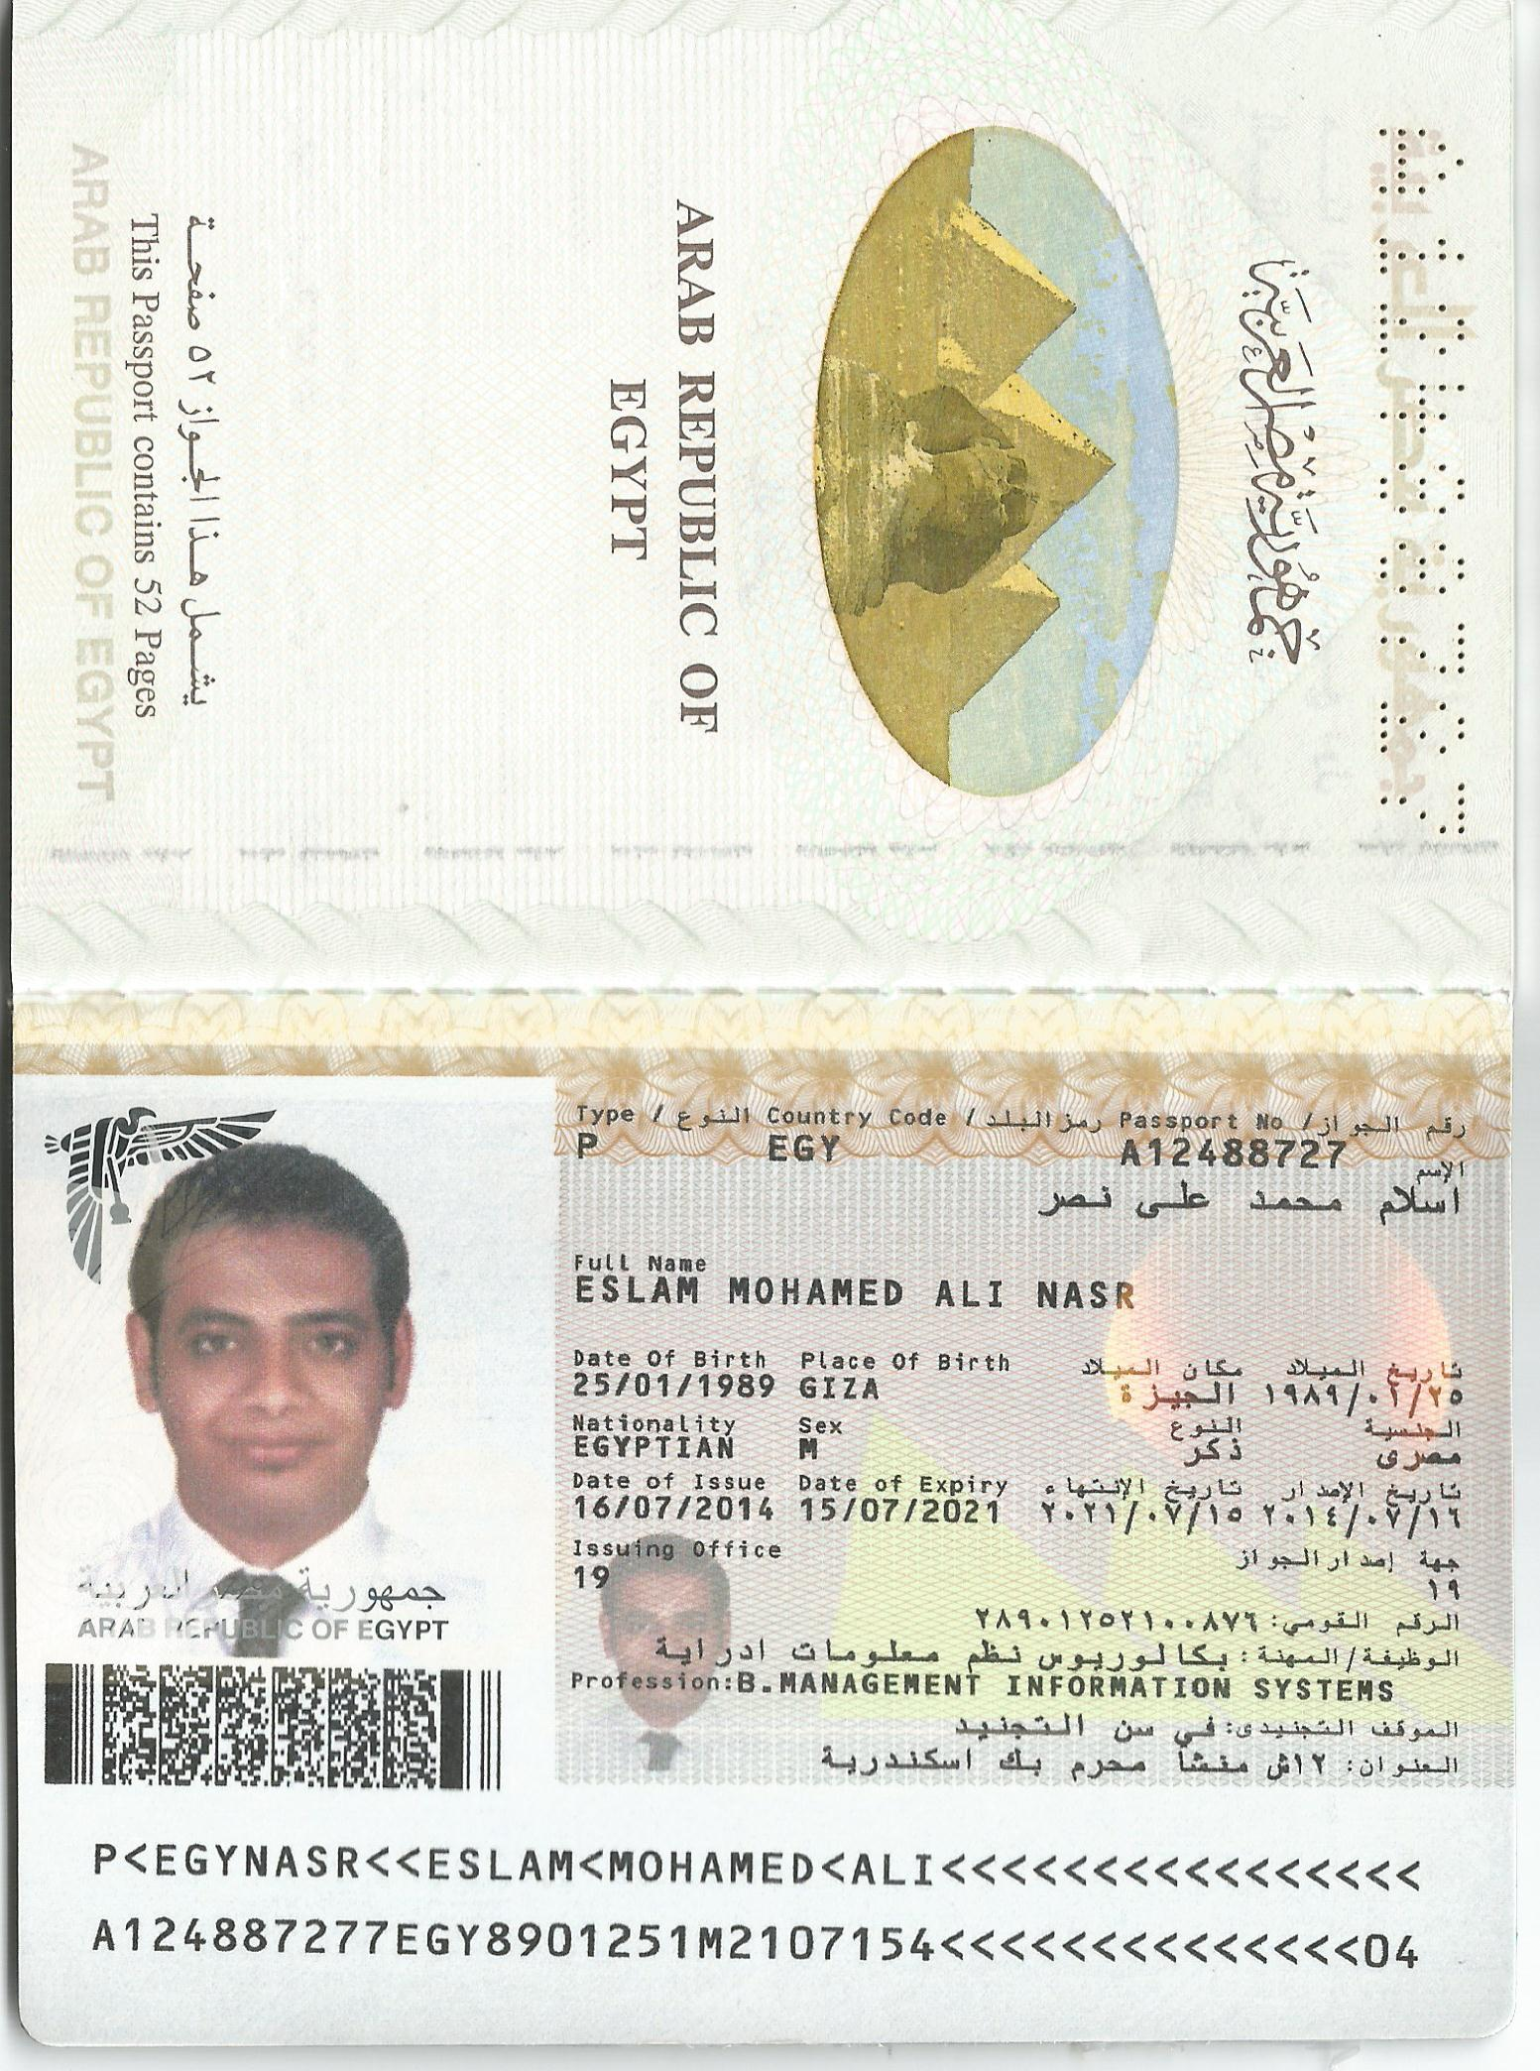

Motor disability

With a physical disability in Dhiray Alaymen

